Club Champs Update – 16th – 17th May 2015

Club Champs is the biggest event of the year for most triathlon clubs in NSW. It is held in Forster (3 hours drive south) & it is when each club in the state is pitted against the other, with the club earning points for each participant & volunteer. Coffs has always fared really well, often taking out the Country Club of the year. Last year we won the Country Club by a landslide & came runner up for NSW as a whole by a measly 2 points. This season we are going back & going back strong to take the main trophy once & for all.

It doesn’t matter how fast or how slow you go (yet the faster you are in your age group the more points you can earn – so start training now ) the more members we have participating the more points we get & the greater chance we have at taking home the trophy. On top of that it is a fantastic weekend to celebrate the season, mingle with like-minded friends & really get to feel a part of a team. It doesn’t matter if you are new to the club or don’t know anyone, by the end of the weekend you will have many more friends & we can assure you that you will have an unforgettable time.

A sign-up sheet has been started & will be located at the timing tent at each club race. Please put down your details (including shirt size) if you are interested in attending so we can get some ideas on numbers & if we need to secure more accommodation etc. Family & friends are welcome to join us (particularly if they want to volunteer for the event & earn us points) so please add their names down as well if they want to come along.

Full details of the weekend, accommodation & race will be sent out to everyone before the event so that you won’t miss a thing. Below is some info for everyone on the weekend, particularly for those who have never been before. Any questions in the meantime please just email Vicki Tillott on vickimt@gmail.com

Race details
The event itself consists of a 1km swim, 30km bike ride & 8km run (very similar distance to Woopi Tri). Our last club race before Club Champs is also this distance just to get a practice hit out for everyone.

For full details of the event go to: http://www.triathlon.org.au/State_Associations/NSW/Events/Triathlon_NSW_Events/SCODY_Triathlon_NSW_Club_Championships/Event_Info.htm

Accommodation & Transportation:
Coffs Tri club arranges & subsidises accommodation for two nights (Friday & Saturday) in Forster. The accommodation is within walking distance to the event. So you will find that once you arrive you won’t need your car again until you leave on Sunday. You will be allocated a room & roommates (requests / partners taken into consideration) before the weekend. Everyone makes their own way down to Forster, but if you need a lift we can pass on your details to other members who have spaces available in their cars.

This year we are also arranging a 12 seater mini bus (with a trailer for bikes) for those who are unable to stay for the weekend but still want to participate & be a part of our team victory. This will leave Coffs early Saturday morning, returning to Coffs Saturday evening.

Cost of weekend:
The weekend (accommodation, bus, entry & t-shirts) is highly subsidised by Coffs Tri Club. The costs are as follows:

Event Entry: $80 (entry fee is $100 & Coffs Tri subsidises $20 per person for this)
Accommodation: $80 (includes 2 nights accommodation & food / drink on Saturday night)
Bus transportation: $15 (includes bus hire, insurance & petrol)
Club Champs T-shirt: Priceless

You enter the race directly through Tri NSW & there will be an automatic $20 discount for Coffs Tri members. Full details of this will come out in the upcoming months. To confirm your accommodation or spot on the bus please deposit appropriate money, with your name listed as a reference, into the Coffs Tri bank account. Coffs Harbour Triathlon Club (BCU), BSB: 704328, Account number: 197693 (S11 if you are transferring from another BCU account). You can also pay Vicki direct at any of the Club races if that is easier for you.

It will be a matter of first in best dressed with regards to accommodation & available spots on the bus.

General Weekend Proceedings
Fri afternoon:
Most of the team arrive sometime Friday afternoon / evening.

Saturday race
Race briefing usually starts mid-morning with the event starting closer to lunchtime continuing into the afternoon, with many waves heading off at various intervals.

Saturday afternoon & evening festivities
Presentation Night at Club Forster where the winners will be announced. Prior to this the club puts on a feed (usually pizza & salad), with a selection of cold beverages (alcoholic & soft) available to all members & volunteers.

Sunday:
Head home at your leisure

Club T-Shirt
Each year we have a new club champs T-shirt, which everyone receives & wears on mass to the presentation night. Last season we had a competition for a slogan (which was won by Michelle Clarke). We will be running a competition again this season for a slogan, design, suggestions for the Club shirt. The winning entry will receive FREE CLUB MEMBERSHIP for 2014-15 (ie: your Coffs Tri fees for the year will be refunded), so definitely one competition to enter. Please send all your entry’s to Vicki at vickimt@gmail.com

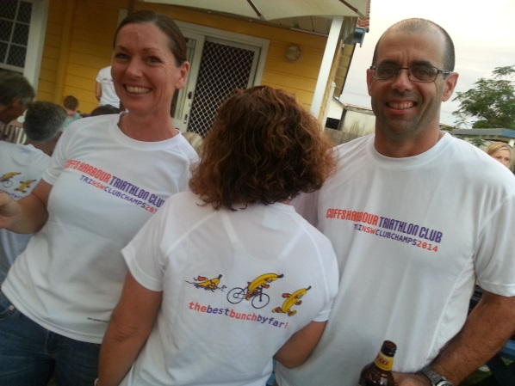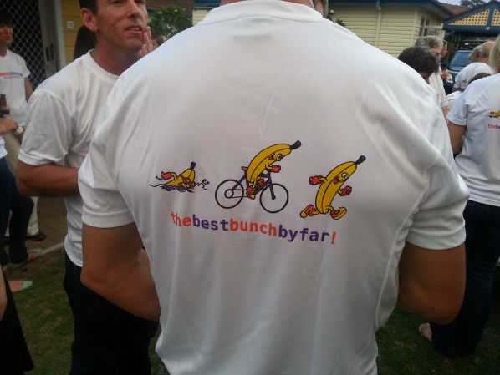

Complaints
THERE WILL BE NONE!!!! But any constructive feedback welcome – just talk with Vicki

